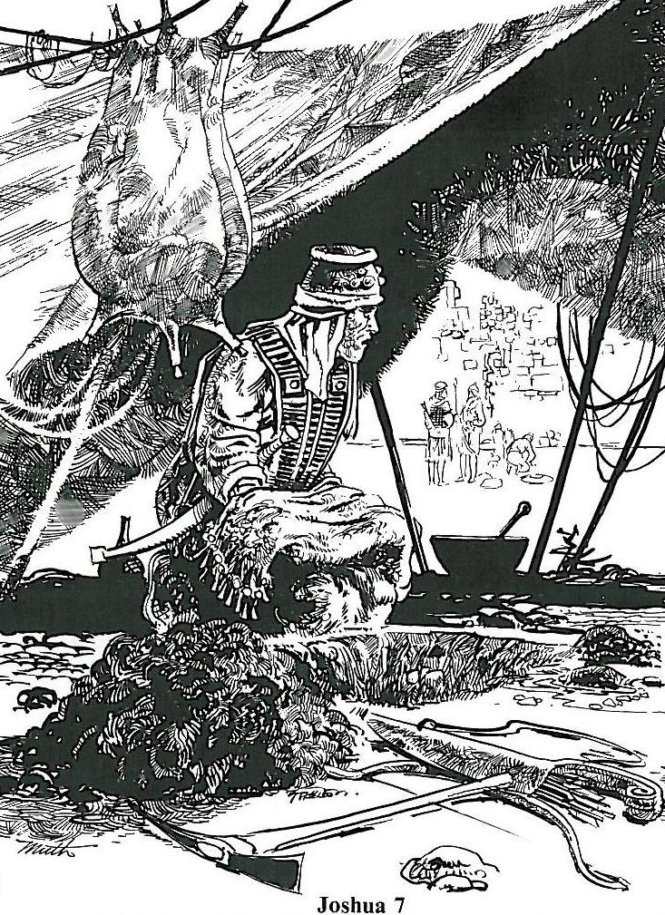
You Shall Not Steal

Luke 12:15 Then [Jesus] said to them, “Watch out! Be on your guard against all kinds of greed; a man’s life does not consist in the abundance of his possessions.”

Stealing is a widespread, common vice, but people pay so little attention to it that the matter is entirely out of hand. If all who are thieves, though they are unwilling to admit it, were hanged on the gallows, the world would soon be empty, and there would be a shortage of both hangmen and gallows. As I have just said, a person steals not only when he robs a man’s strongbox or his pocket, but also when he takes advantage of his
neighbor.
Large Catechism 1, 224

Read Joshua 6:17-19; 7:1-26
1. How much of Jericho was devoted to the LORD? What would happen if the Israelites took anything?
2. Why was God angry with the Israelites?
3. How did just a few men in Ai defeat the Israelite force?
4. How did Joshua discover the thief?
5. What had Achan stolen? From whom had he stolen it?
6. How did God deal with Achan's sin?

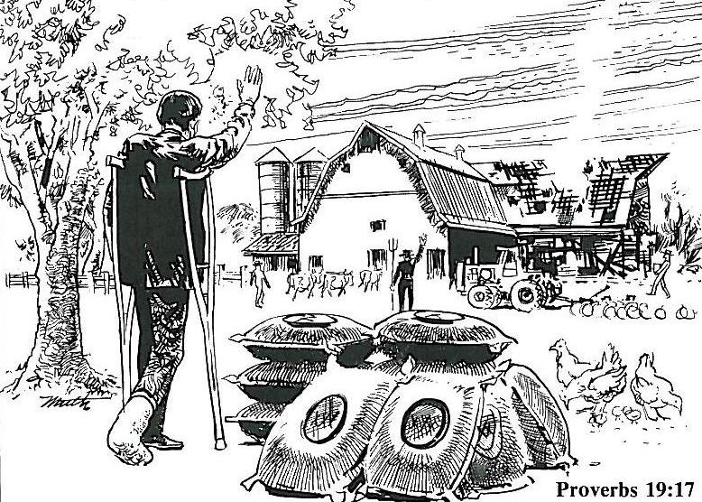

Proverbs 19:17 He who is kind to the poor lends to the LORD, and he will reward him for what he has done.
1. What problems has the farmer in the picture encountered?
2. What have his friends and neighbors done to help?
3. Which part of the 7th commandment does this picture illustrate?
4. From whom does every earthly possession come?
5. What does God ask us to do with our possessions?
6. What is “stewardship”?
2 Corinthians 8:9; 9:7-8
Deuteronomy 16:17
1 Corinthians 16:1-2

Hebrews 13:5 Keep your lives free from the love of money and be content with what you have, because God has said, “Never will I leave you; never will I forsake you.”

